SAMPLE SOLICITATION LETTER
5.5.21

Date
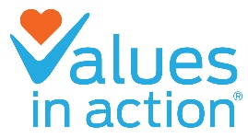

Name
Organization
Address
Address2
6700 Beta Dr. Ste. 120
Mayfield, OH 44143
440.442.5683
viafdn.org
City, ST Zip

Dear _________,

On May 5, 2021, Values-in-Action Foundation will honor Rob Ruhlman & Family (Preformed Line Products), Nicholas Bertram (The Giant Company), David Gilbert (Greater Cleveland Sports Commission & Destination Cleveland), Peter Georgescu (Young & Rubicam), Leon Bibb (Cleveland Broadcast Legend, 3News Reporter and Commentator), and Chuck Kyle (Head Football Coach, St. Ignatius High School) at its annual VALUES MATTER Awards Dinner. As chairs for the event, we are thrilled to share with you the opportunity to honor these deserving individuals who are committed to making values a priority in the workplace and throughout the community.

We recognize that you have many requests in front of you, but we would greatly appreciate your support of this one, not only to honor The Ruhlman Family, Nicholas, David, Peter, Leon and Chuck, but also to support a wonderful cause by purchasing a table and attending.

As a country and community, we are living in unprecedented and heart wrenching times. COVID-19 has not only created a health and economic crisis but a social and humanitarian crisis as well. Values-in-Action is a culture-change and leadership organization that has trained almost one million students across its 26 years, and it recognizes that crises often times open eyes and move hearts to change.

Through its Project Love school workshops, Values-in-Action delivers social-emotional, character-building programming to more than 300 schools in 77 counties throughout Ohio. Its programming has helped to raise graduation rates in the Cleveland Metropolitan School District from 47% to 85%, while decreasing bullying and violence, increasing access to jobs, and enhancing students’ success in life. In addition to this, the organization’s
Be Kind® STICK TOGETHER® anti-bullying, kindness program has reached over 735,000 students in ALL 50 states.

The kind of country and world that we collectively build depends in large part on our children, how they treat others and how they exhibit leadership and build relationships. That is what Values-in-Action is about.

Enclosed with this letter is the information for you to make a contribution decision. Thank you for considering.

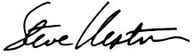
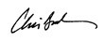
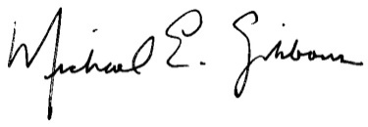
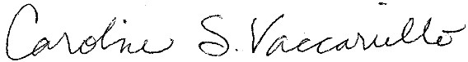
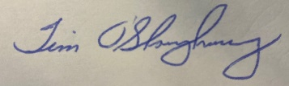
Thank you,

Chris Brand Mike Gibbons Steve Kestner
General Co-Chair General Co-Chair General Co-Chair
The Giant Company Brown Gibbons Lang & Company BakerHostetler

Tim O'Shaughnessy Carrie Vaccariello
General Co-Chair General Co-Chair
Preformed Line Products Preformed Line Products

